***An***

***Mini Project Report***

***on***

**SAR IMAGE COLORIZATION FOR COMPREHENSIVE**

**INSIGHTS USING DEEP LEARNING**

***submitted in partial fulfillment of the requirement for the award of degree***

**BACHELOR OF TECHNOLOGY**

**In**

**COMPUTER SCIENCE AND ENGINEERING**

#### *Of*

##### JAWAHARLAL NEHRU TECHNOLOGICAL UNIVERSITY- HYDERABAD

***Submitted By***

## JVR VINAYAK 215U1A0574

## K SAI VARSHITH 215U1A0581

## K VAMSHI 215U1A0575

## L LOKESH NAYAK 215U1A05A7

## Under the guidance of

**Mr.M.Praveen**

Assistant Professor

**DEPARTMENT OF COMPUTER SCIENCE AND ENGINEERING**

### AVN INSTITUTE OF ENGINEERING AND TECHNOLOGY

### Approved by AICTC, Accredited by NAAC & NBA, Affiliated to JNTUH

Koheda Road, M.P.Patelguda Post, Ibrahimpatnam (M),Ranga Reddy Dist, T.G.S., India.

##### **2024-25**



## CERTIFICATE

This is to certify that the project report entitled **SAR Image Colourization For Comprehensive Using Deep Learning** submitted by **JVR Vinayak,K Sai Varshith,K Vamshi,L Lokesh Nayak** to the AVN Institute of Engineering & Technology, in partial fulfillment for the award of the degree of **B. Tech in Computer Science and Engineering** is a *bonafide* record of mini project work carried out by him under our supervision. The contents of this report, in full or in parts, have not been submitted to any other Institution or University for the award of any degree or diploma.

|  |  |  |
| --- | --- | --- |
| **Guide** | **Project Coordinator** | **HOD** |
| Mr.M.Praveen | Ms.M.Kanakeshwar reddy | Mr.Dr.V.Goutham |
| Assistant Professor | Assistant Professor | Professor |

**External Examiner**



## DECLARATION

I declare that this project report titled **SAR Image Colourization For Comprehensive Using Deep Learning** submitted in partial fulfillment of the degree of **B. Tech in Computer Science and Engineering** is a record of original work carried out by me under the supervision of **Mr.M.Praveen**, and has not formed the basis for the award of any other degree or diploma, in this or any other Institution or University. In keeping with the ethical practice in reporting scientific information, due acknowledgements have been made wherever the findings of others have been cited.

## JVR Vinayak 215U1A0574

## K Sai Varshith 215U1A0581

## K Vamshi 215U1A0575

## L Lokesh Nayak 215U1A05A7



Sample sheet 4

## ACKNOWLEDGMENT

It gives me great pleasure to present the report of the Mini Project Work undertaken during B.Tech. Final Year. I owe a special debt of gratitude to my Project Guide Mr.M.Praveen(Asst. professor), Department of Computer Science and Engineering, for their constant support and guidance throughout the course of my work. It is only through their efforts that my endeavors have seen the light of day.

My deepest thanks to my Project Coordinator Mr.M.Kanakeshwar Reddy (Asst. professor), Department of Computer Science and Engineering, for guiding and correcting various documents of mine with attention and care.

I also take this opportunity to acknowledge the contribution of Dr V Goutham, (professor)Head of the Department of Computer Science and Engineering for his full support and assistance during the development of the project.

I would also like to acknowledge the contribution of all faculty members of the department for their kind assistance and cooperation during the development of my project.

Last but not least, I acknowledge my parents and friends for their contribution to the completion of the project.

## JVR Vinayak 215U1A0574

## K Sai Varshith 215U1A0581

## K Vamshi 215U1A0575

## L Lokesh Nayak 215U1A05A7

## ABSTRACT

This project seeks to improve the usability and interpretability of Synthetic Aperture Radar (SAR) images by transforming grayscale images into informative color images using deep learning. The vast amounts of SAR data generated for applications such as surveillance and environmental monitoring are often underused because of the limited interpretability of grayscale images, which hampers efficient decision-making. To address this, the project employs a CycleGAN model that leverages unsupervised learning techniques to perform high-quality SAR image colorization. The dataset, sourced from Kaggle, was preprocessed to ensure it met model requirements, including resizing to 256x256 pixels and normalizing pixel values. The CycleGAN model, consisting of generators and discriminators, was trained for 4577 epochs to effectively convert grayscale images into colorized outputs. The results show significant improvements in SAR data analysis, enhancing decision-making in real-time applications such as disaster management, environmental monitoring, and security surveillance. This system automates the process of SAR image analysis, enabling the quick identification of critical patterns and anomalies, thereby improving situational awareness. By transforming grayscale SAR data into more interpretable and visually accessible formats, the project highlights the potential of deep learning models to generate actionable insights. Future work will focus on expanding the system to handle real-time video colorization and creating more user-friendly applications, further improving accessibility and usability across various sectors. This approach not only enhances the interpretability of SAR images but also contributes to more effective monitoring and decision-making in critical situations.

iii

## TABLE OF CONTENTS

#### 

|  |  |
| --- | --- |
| **DESCRIPTION** | **PAGE NUMBER** |
|  |  |
| **LIST OF FIGURES** | **i** |
| **LIST OF TABLES** | **ii** |
| **ABSTRACT** | **iii** |
| **ABBREVIATIONS/ NOTATIONS/ NOMENCLATURE** | **1-3** |
| 1. **INTRODUCTION** | **4-8** |
| 1.1 Motivation | 4 |
| 1.2 Problem Statement | 4 |
| 1.3 Purpose | 4 |
| 1.4 Scope | 5 |
| 1.5 Project Objective | 5 |
| 1.6 Limitations | 6 |
| 1.7 The morse code | 8 |
| 2. **LITERATURE SURVEY** | **9-12** |
| 2.1 Introduction | 9 |
| 2.2 Existing System | 10 |
| 2.3 Proposed System | 12 |
| 3.  **SYSTEM ANALYSIS** | **13-19** |
| 3.1 Functional Requirements | 13 |
| 3.2 Non-Functional Requirements | 16 |
| 3.3 System Requirements | 19 |
|  |  |
|  |  |
|  |  |
|  |  |

|  |  |
| --- | --- |
| 4**. SYSTEM DESIGN** | **21-30** |
| 4.1 UML Diagrams | 21 |
| 4.1.1 Use Case Diagram | 22 |
| 4.1.2 Class Diagram | 23 |
| 4.1.3 Sequence Diagram | 26 |
| 4.1.4 Activity Diagram | 28 |
| 4.1.5 Collaboration Diagram | 30 |
| 5. **IMPLEMENTATION & RESULT** | **31-63** |
| 5.1 Method of Implementation | 31 |
| 5.1.1 Modules | 32 |
| 5.1.2 Software Environment | 32 |
| 5.2 Output Screens | 61 |
|  |  |
| 6. **SYSTEM TESTING** | **64-65** |
| 6.1 Types of Testing | 64 |
| 6.2 Test cases | 65 |
| 7.  **CONCLUSION** | **66** |
| 7.1 Project Conclusion | 66 |
| 7.2 Future Enhancement | 66 |
| **REFERENCES** | **67** |
| **APPENDIX** | **68-70** |

|  |  |  |
| --- | --- | --- |
|  |  |  |
| **LIST OF FIGURES** |  |
| **FIGURE** | **TITLE** | **PAGE NUMBER** |
| 4.1 | Use Case Diagram | 23 |
| 4.2 | Class Diagram | 25 |
| 4.3 | Sequence Diagram | 27 |
| 4.4 | Activity Diagram | 29 |
| 4.5 | Collaboration Diagram | 30 |
| 5.1 | Download Python | 54 |
| 5.2 | Python 3.9 | 55 |
| 5.3 | Specific Release | 55 |
| 5.4 | Files | 56 |
| 5.5 | Install Python 3.9 | 57 |
| 5.6 | Open Python 3.9 | 57 |
| 5.7 | Installed Successfully | 58 |
| 5.8 | Select Command Prompt | 59 |
| 5.9 | Select Python Version | 59 |
| 5.10 | Idle Python 3.9 | 60 |
| 5.11 | Save the file  i | 60 |

|  |  |  |
| --- | --- | --- |
|  |  |  |
| **LIST OF TABLES** |  |
| **TABLE** | **TITLE** | **PAGE NUMBER** |
| 6.1 | Test Cases | 65 |
|  |  |  |
|  |  |  |
|  |  |  |
|  | ii |  |

**ABBREVIATIONS/NOTATIONS**

**/NOMENCLATURE**

### ****Abbreviations****

* **SAR**: Synthetic Aperture Radar
* **CNN**: Convolutional Neural Network
* **GAN**: Generative Adversarial Network
* **CycleGAN**: Cycle-Consistent Generative Adversarial Network
* **RMSE**: Root Mean Square Error
* **SSIM**: Structural Similarity Index Measure
* **PSNR**: Peak Signal-to-Noise Ratio
* **RGB**: Red, Green, Blue
* **GPU**: Graphics Processing Unit
* **DL**: Deep Learning
* **AI**: Artificial Intelligence
* **RL**: Reinforcement Learning
* **NLP**: Natural Language Processing
* **IoT**: Internet of Things
* **GIS**: Geographic Information Systems
* **TIR**: Thermal Infrared Radiometer
* **MSE**: Mean Squared Error
* **DNN**: Deep Neural Network

### ****Notations****

* **X**: Input grayscale SAR image
* **Y**: Target colorized SAR image (ground truth)
* **G**: Generator function of the CycleGAN
* **D**: Discriminator function of the CycleGAN
* **L(G, D)**: Loss function for training the CycleGAN model, combining adversarial and cycle consistency losses
* **λ**: Hyperparameter balancing the weight of the cycle-consistency loss
* **t**: Temporal variable or iteration during model training
* **I(x)**: Input image from the dataset
* *I(x)**: Colorized output image generated by the CycleGAN model
* **X_A**: Grayscale image from domain A (source domain, i.e., SAR images)
* **X_B**: Colorized image from domain B (target domain, i.e., colorized SAR images)
* **MSE(X, Y)**: Mean Squared Error between original and colorized SAR images for evaluation
* **SSIM(X, Y)**: Structural Similarity Index Measure between original and colorized SAR images for evaluation

### ****Nomenclature****

* **CycleGAN Model**: A deep learning architecture used to generate realistic colorized images from grayscale SAR images through adversarial training, ensuring cycle-consistency between domains A and B.
* **Generator**: A neural network used to generate synthetic data (colorized images in this case) from input data (grayscale SAR images). It aims to create output indistinguishable from real data.
* **Discriminator**: A neural network used to distinguish between real and generated images. The discriminator’s role is to assess the quality of the colorized images produced by the generator.
* **Adversarial Loss**: A loss function used in GANs to train the generator and discriminator, encouraging the generator to produce realistic images that fool the discriminator.
* **Cycle Consistency Loss**: A loss function used in CycleGAN to ensure that images generated from domain A (grayscale) can be converted back to their original form and vice versa, ensuring that the transformation between the domains is consistent.
* **Training Epoch**: One full pass through the training dataset during model training.
* **Batch Size**: The number of training examples utilized in one forward/backward pass during training. A larger batch size leads to more stable training but requires more memory.
* **Learning Rate**: A hyperparameter that controls the speed at which the model’s weights are updated during training.

## CHAPTER 1

**INTRODUCTION**

**1.1. Motivation**

The vast amount of SAR data generated for surveillance and environmental monitoring often remains underutilized due to its grayscale nature. This limitation reduces its effectiveness in real-time decision-making. Leveraging deep learning for colorization addresses this issue, making SAR data more actionable and user-friendly. The motivation stems from the need to make advanced remote sensing technologies accessible and effective for diverse applications, including disaster response and environmental assessments.

**1.2. Problem Statement**

SAR images are extensively used in remote sensing but are limited by being grayscale, making them harder to interpret. The inability to discern fine details in grayscale data restricts their usability in critical applications. Existing models like Pix2Pix yield suboptimal results due to inefficiencies in capturing intricate mappings. The CycleGAN model, introduced in this project, is expected to overcome these challenges, enhancing interpretability by generating high-quality colorized outputs that align with real-world expectations.

**1.3 Purpose**

The purpose of this project is to bridge the usability gap in SAR imagery by employing advanced deep learning techniques for colorization. By enhancing SAR data interpretability, this project aims to improve situational awareness and decision-making processes across diverse fields. Transforming grayscale data into

**1.4 Scope**

The project focuses on developing a CycleGAN-based framework to transform grayscale SAR images into colorized versions. This transformation has implications for several fields, including:

* Remote sensing: Enhanced environmental monitoring and land-use analysis.
* Security surveillance: Improved interpretation of activity in sensitive areas.
* Disaster management: Quick assessment of affected regions using vivid imagery.

**1.5 Project Objectives**

The main objective of this project is to enhance the usability and interpretability of grayscale Synthetic Aperture Radar (SAR) images by transforming them into colorized representations using advanced deep learning models, particularly the CycleGAN architecture. Specific objectives include:

* **Implement CycleGAN for SAR Image Colorization**: Utilize the CycleGAN model to learn the mapping between grayscale SAR images and their corresponding colorized versions. The model will be trained to generate high-quality color images that maintain the integrity of the original information while improving visual clarity and interpretability.
* **Enhance Decision-Making in Remote Sensing Applications**: The colorization of SAR images can significantly improve their usability in real-time decision-making. This project aims to enhance situational awareness for applications such as environmental monitoring, disaster response, and surveillance. Colorized images can reveal subtle details in the landscape that are not easily discernible in grayscale, improving the accuracy of decisions made based on the data.
* **Demonstrate the Effectiveness of Unsupervised Deep Learning Techniques**: One of the goals of this project is to showcase the power of unsupervised learning techniques in image colorization. CycleGAN, as an unsupervised model, does not require paired data (i.e., grayscale and color versions of the same images), making it highly suitable for SAR image colorization tasks where labeled datasets may not be easily accessible.
* **Ensure Feasibility for Low-Resource Environments**: Given the high computational demands of training deep learning models, this project aims to optimize the CycleGAN model to be deployable on systems with limited computational resources, such as remote sensing platforms or field devices. This would make the technology more accessible to organizations or regions with less powerful hardware.
* **Evaluate Model Performance on Diverse SAR Datasets**: The project will assess the model's performance on multiple SAR datasets, ensuring that it can generalize well across different environments, including urban,

**1.6 Limitations**

While the proposed approach using CycleGAN for SAR image colorization offers significant benefits, it comes with several limitations that need to be addressed for effective implementation and deployment. These limitations include:

* **High Computational Requirements**: Training deep learning models, particularly CycleGAN, requires substantial computational power. The model’s architecture involves multiple generators and discriminators, which demand significant GPU resources, high memory, and long processing times. This can make the training process slow and resource-intensive, potentially limiting its accessibility for organizations or regions with limited computational infrastructure.
* **Dependency on High-Quality Datasets**: The success of the CycleGAN model in generating high-quality colorized images depends heavily on the quality and diversity of the training dataset. Since SAR images are often noisy and can vary greatly in terms of terrain, environmental conditions, and sensor characteristics, poor data quality can degrade the performance of the model. Inaccurate colorization due to low-quality input data can undermine the interpretability of the final output.
* **Limited Real-Time Processing Capability**: While CycleGAN can produce impressive results in offline scenarios, real-time processing remains a challenge due to the model’s complexity. The current hardware configurations used in this project may not support real-time processing or rapid deployment in operational scenarios, such as live environmental monitoring or disaster response. Optimizing the model for real-time use would require significant improvements in efficiency and model speed.
* **Generalization Across Diverse Environments**: SAR imagery varies widely based on geographic location, weather conditions, and seasonal changes. The CycleGAN model may struggle to generalize across all types of SAR data, especially if the dataset used for training does not represent a wide range of environments. This limitation could affect the model’s ability to perform well in diverse real-world conditions, potentially leading to inaccuracies in the colorized output for certain geographic or climatic settings.
* **Limited Interpretability of Results**: While the colorization of SAR images can improve their visual appeal and interpretability, it may introduce challenges in terms of how accurately the colorized images represent the original grayscale data. The transformation process might unintentionally introduce artifacts or misinterpretations in the images, especially if the model has not been adequately trained or if it overfits the
* **1.7 The Morse Code-Anomaly Recognition for Suspicious Behavior**

The Morse Code, invented by Samuel Morse and Alfred Vail in the early 19th century, was a revolutionary method of communication that enabled the transmission of textual information over long distances using simple dot-and-dash sequences. It was one of the first practical applications of telegraphy and laid the foundation for modern telecommunications, enabling faster and more efficient communication. The simplicity and accessibility of Morse Code made it an essential tool for military, maritime, and emergency services, especially in situations where other forms of communication were unavailable or unreliable.

In this project, the concept of Morse Code serves as a source of inspiration for transforming the inherent simplicity of grayscale SAR imagery into a more accessible and informative form. Just as Morse Code brought clarity to communication by encoding messages in a visually structured manner, this project aims to enhance SAR data by colorizing it, thus making it more understandable and actionable for a wide range of applications.

The transformation of grayscale SAR images into vibrant colorized visuals represents a step forward in improving the interpretability of remote sensing data. The colorized images, much like the role of Morse Code in breaking communication barriers, provide additional layers of information that are easier to interpret, especially for non-experts or decision-makers.

Moreover, by bridging the gap between complex data and user understanding, this project can be seen as an extension of the principle of Morse Code: making complex, raw information accessible to a wider audience. Just as Morse Code was critical in enhancing the transmission of messages in the early telecommunication era, colorized SAR imagery has the potential to revolutionize

## CHAPTER 2

**LITERATURE SURVEY**

**2.1 Introduction**

The field of Synthetic Aperture Radar (SAR) imaging has seen rapid advancements in recent years, contributing to a variety of applications such as environmental monitoring, disaster management, agriculture, and surveillance. However, one of the major challenges with SAR images is their inherent grayscale nature, which makes them difficult to interpret, especially for non-experts. Grayscale SAR images often lack the visual cues necessary for understanding intricate details such as vegetation type, land usage, or water bodies, leading to reduced usability in critical decision-making processes.

In this context, image colorization techniques have emerged as a promising solution to enhance the interpretability of SAR data. Traditionally, colorization has been applied to other types of images, such as black-and-white photographs or medical images, but its application to SAR images remains an ongoing research challenge. In recent years, deep learning models, particularly Generative Adversarial Networks (GANs), have shown great potential in transforming grayscale images into colorized outputs by learning the underlying data distribution. Among these models, CycleGAN has emerged as a state-of-the-art technique due to its ability to perform image-to-image translation tasks without paired training data.This section reviews the existing systems, methodologies, and models that have been explored in SAR image colorization and related fields, leading to the proposed system based on CycleGAN for SAR image enhancement.

**2.2 Existing System**

Several methods for SAR image colorization have been proposed in the past, ranging from traditional image processing techniques to advanced deep learning-based approaches. These methods can broadly be categorized into **manual color mapping**, **image processing techniques**, and **deep learning-based models**. Each of these methods has its strengths and weaknesses when applied to SAR images.

1. **Manual Color Mapping**: Traditional methods of SAR image enhancement often involve manual color mapping, where experts manually assign colors to different image features based on their knowledge of the image content. While this approach can yield aesthetically pleasing results, it is extremely time-consuming and requires domain expertise. Furthermore, manual methods do not scale well to large datasets and cannot be easily automated, making them impractical for large-scale or real-time applications.
2. **Image Processing Techniques**: Image processing algorithms, such as histogram equalization, contrast adjustment, and edge detection, have been applied to SAR images to improve their visual appeal. These techniques can enhance certain image features, such as contrast or boundaries, but they do not effectively address the underlying issue of grayscale interpretation. While these methods are computationally efficient, they are often limited by their reliance on predefined color schemes or transformations, which may not capture the inherent complexity of the data.
3. **Deep Learning-Based Models**: Recent advancements in deep learning have led to the development of more sophisticated methods for image colorization. Convolutional Neural Networks (CNNs) have been applied to colorize black-and-white photographs and medical images, achieving promising results. However, CNN-based models often require large paired datasets for training, where each grayscale image is paired with a corresponding color image. This is a significant limitation when dealing with SAR imagery, as paired SAR datasets (i.e., grayscale images alongside their colorized counterparts) are rare and difficult to obtain.

In the realm of **Generative Adversarial Networks (GANs)**, models such as **Pix2Pix** have been used for image translation tasks. Pix2Pix is a conditional GAN that learns a mapping between paired datasets, such as transforming grayscale images into color images. While Pix2Pix has demonstrated success in various applications, its reliance on paired data restricts its applicability in SAR image colorization, where paired datasets are not readily available.

1. **Unsupervised Learning with GANs**: To address the limitations of paired data, **unsupervised learning** techniques have gained traction, particularly **CycleGANs**. Unlike traditional GAN models, CycleGANs do not require paired training data. Instead, they use two separate domains—grayscale and colorized images—and learn to map between these domains through adversarial training. CycleGANs are particularly useful for tasks where labeled data is scarce or unavailable, making them a suitable choice for SAR image colorization. However, while CycleGAN has been successful in other domains (such as translating images between different artistic styles or converting photos to paintings), its application to SAR images remains a relatively new area of research. CycleGAN models face challenges in generating high-fidelity colorized outputs and may struggle to capture the intricate details of SAR images, especially in complex environments.

**2.3 Proposed System**

The proposed system aims to address the limitations of existing systems by leveraging **CycleGAN**, a powerful unsupervised deep learning model, to perform SAR image colorization. The proposed CycleGAN-based system has several key advantages over traditional and existing methods:

1. **Unsupervised Learning**: One of the major innovations of CycleGAN is its ability to learn mappings between image domains without requiring paired data. This is particularly useful for SAR image colorization, as paired SAR datasets are difficult to obtain. By learning the distribution of grayscale and colorized images separately, CycleGAN can effectively generate colorized versions of grayscale SAR images without needing a one-to-one correspondence between the two domains. This approach significantly reduces the dataset requirements and makes the model more scalable.
2. **Cycle Consistency**: CycleGAN ensures that the transformation between the two domains (grayscale and colorized images) is **cycle-consistent**. This means that an image can be colorized and then transformed back into grayscale without significant loss of information. This feature is particularly important for SAR images, as it ensures that no critical information is lost during the colorization process, preserving the integrity of the original data while making it more visually interpretable.
3. **Improved Interpretability**: The colorization of SAR images using CycleGAN can greatly improve their interpretability, making them more accessible to a broader range of users, including non-experts. The introduction of color allows for the visual enhancement of key features in the images, such as terrain types, vegetation, and water bodies, which are often difficult to distinguish in grayscale. This can improve decision-making processes in various applications, such as disaster monitoring, urban planning, and agricultural management.
4. **High-Quality Colorization**: CycleGAN is designed to generate high-quality, realistic images by learning from the complex data distributions .

## CHAPTER 3

**SYSTEM ANALYSIS**

**3.1 Functional Requirements**

Functional requirements refer to the specific tasks and capabilities that the system must provide to satisfy the project goals. These are the key operations that the system must support to ensure its effectiveness and utility. In the case of SAR Image Colorization, the functional requirements define the essential actions the system must perform in order to process and enhance grayscale SAR images using deep learning models. Below are the detailed functional requirements:

1. **Grayscale SAR Image Input**: The system must accept grayscale SAR images as input. These images will form the raw material for the image colorization process. The input images should be in standard formats, such as PNG, JPEG, or TIFF, and must conform to certain quality standards to ensure they are usable by the system. The system should support the ability to handle varying image sizes and resolutions, as SAR images may differ in dimension based on the sensor used to capture them.
2. **CycleGAN Model for Image Translation**: The core of this system is the CycleGAN model, which will be responsible for transforming grayscale SAR images into colorized versions. The CycleGAN (Cycle-Consistent Generative Adversarial Network) will be trained to learn the mapping between grayscale images and their corresponding colorized counterparts. The system must support the training of this model, which will involve iteratively improving the model’s ability to predict realistic colorization outputs through the adversarial training process. This will require managing the CycleGAN’s two networks—one for generating colorized images (the generator) and another for distinguishing between real and generated images (the discriminator).
3. **Training and Testing of CycleGAN**: The system must facilitate both the training and testing of the CycleGAN model. Training involves feeding the network with a large dataset of grayscale SAR images and allowing the model to learn how to generate colorized outputs. The testing phase will involve evaluating the trained model’s performance on unseen grayscale images to ensure that the colorization model generalizes well and produces satisfactory results. The system should include the ability to track the progress of training and adjust hyperparameters for better performance.
4. **Output of Colorized SAR Images**: Once the CycleGAN model has processed the input grayscale SAR images, the system must produce and output colorized images. These output images should be in a format that is compatible with image viewers and analysis tools, such as PNG, JPEG, or TIFF. Additionally, the output images should maintain a high quality that is visually coherent and suitable for interpretability by end-users or analysts. It’s also necessary for the output to preserve the original size and resolution of the input image to avoid distortion or loss of detail during the transformation process.
5. **Performance Evaluation**: To ensure the effectiveness of the CycleGAN model, the system must evaluate the quality of the colorized images. This evaluation should be based on objective image quality metrics such as **Peak Signal-to-Noise Ratio (PSNR)**, **Structural Similarity Index (SSIM)**, and **Mean Squared Error (MSE)**. These metrics will help assess how closely the generated colorized images resemble ground truth data or expected outputs. Additionally, user feedback may be incorporated into the evaluation phase, especially if the system is intended for practical use in remote sensing or environmental monitoring.
6. **Real-Time Processing**: Although the training phase may require significant computational resources, the system should ensure that inference (the process of generating colorized images from grayscale inputs) can be performed in real-time or near real-time. This will ensure that the system can be used in time-sensitive applications, such as disaster monitoring or emergency response, where speed is critical. Efficient inference will also enhance the system’s usability for remote sensing operations.
7. **User Interface** : While not strictly required for the core functionality, the system could benefit from a user interface, especially for users who may not have technical expertise. This interface should allow users to upload grayscale SAR images, view the colorized outputs, and download the results. The interface should be simple to navigate, intuitive, and offer minimal setup or configuration. For example, users could drag and drop images into the system and receive the colorized images in the same format.
8. **Model Retraining** : As new datasets or advancements in SAR imaging technology become available, the system should support the ability to retrain the CycleGAN model with updated datasets. This would allow the system to continually improve over time, maintaining its relevance and accuracy for new SAR images that may have different characteristics from those used in the original training phase. Additionally, retraining should be seamless and require minimal intervention from the user.

**3.2 Non-Functional Requirements**

Non-functional requirements describe the operational aspects of the system, such as its performance, reliability, scalability, security, and usability. These requirements ensure that the system not only performs the desired functions but also meets the expectations of users in terms of quality, speed, and overall experience. Below are the detailed non-functional requirements for the SAR Image Colorization system:

1. **Performance**:
   * **Speed and Efficiency**: The system should be designed to process grayscale SAR images and generate colorized outputs efficiently. While training the CycleGAN model may require substantial time, the inference phase—where new images are colorized—should be completed in a reasonable timeframe, ideally within seconds to a few minutes depending on the hardware.
   * **Scalability**: The system should be capable of handling a growing number of SAR images and supporting the processing of large datasets. This means that as the number of images increases, the system should not slow down significantly. The scalability of the system is essential, especially when deployed in large-scale remote sensing applications.
2. **Reliability**:
   * **Error Handling**: The system must be able to handle errors robustly. It should detect and report issues such as invalid image formats, corrupt data, or model training failures. Clear error messages should be provided to the user, allowing them to troubleshoot and resolve problems.
   * **Fault Tolerance**: The system should be resilient to failures during image processing, model training, or inference. In the event of an error, the system should be able to recover gracefully and resume from the last checkpoint without losing significant progress.
3. **Security**:
   * **Data Privacy**: SAR images may contain sensitive information, particularly in defense and environmental monitoring contexts. The system must ensure that images are processed in a secure environment, and personal or sensitive data must not be exposed during the image processing pipeline.
   * **Access Control**: If the system includes a cloud-based interface or web portal, robust user authentication and authorization mechanisms should be implemented. Only authorized users should have access to the images or the ability to initiate processing tasks.
4. **Usability**:
   * **User Experience**: The system should be designed to be user-friendly, especially for users who are not experts in machine learning or SAR imagery. The interface should allow users to easily upload images, view results, and perform actions without extensive training or technical knowledge.
   * **Documentation**: Comprehensive documentation should be provided for both the users and developers. The user manual should explain how to interact with the system, upload images, and interpret the results, while the developer documentation should cover the system architecture, dependencies, and guidelines for customization.
5. **Maintainability**:
   * **Codebase Documentation**: The system’s codebase should be well-documented, with clear comments explaining the purpose of various components and functions. This will make it easier for future developers to maintain or extend the system.
   * **Modular Design**: The system should be modular, with clearly defined components for image processing, model training, evaluation, and user interaction. This modularity will allow for easier updates, such as incorporating new deep learning techniques or integrating additional SAR image datasets.
6. **Portability**:
   * The system should be portable across different operating systems and environments. It should work seamlessly on Windows, Linux, and macOS platforms, and it should be adaptable for deployment in cloud environments such as AWS or Google Cloud. Ensuring portability will help expand the system’s reach to a wide variety of users and organizations.
7. **Resource Efficiency**:
   * **Memory and Storage**: The system should be designed to efficiently use system resources, including memory and disk storage. Given the large size of SAR image datasets, it is critical to manage memory efficiently to avoid crashes and slowdowns.
   * **Computational Efficiency**: The system should be optimized to run on hardware with limited computational resources, such as personal computers or low-cost cloud instances, while maintaining a balance between performance and resource consumption.

**3.3 System Requirements**

#### ****Hardware Requirements****:

1. **Processor**:
   * A modern multi-core processor is still recommended for smooth performance. An Intel Core i5 or i7 processor (or an AMD Ryzen equivalent) is ideal for running Streamlit applications efficiently. A more powerful processor will be advantageous if large-scale image processing or model retraining is required on the deployed system.
2. **RAM**:
   * Streamlit applications can be memory-intensive, especially when handling high-resolution SAR images. A minimum of 8 GB of RAM is recommended for the smooth execution of the colorization tasks, but 16 GB of RAM or more will provide better performance, especially when serving multiple users or handling large datasets.
3. **Graphics Processing Unit (GPU)**:
   * If you’re running the deep learning model for colorization on the server or the local machine, a GPU is necessary to speed up inference and provide real-time processing. A **dedicated GPU** like NVIDIA’s **GTX 1060** or higher with at least 4 GB of VRAM is recommended for running the CycleGAN model.
   * If you don’t have access to a local GPU, you can deploy the system to a cloud-based platform (such as Google Cloud or AWS) that supports GPU instances. This will enable faster image colorization.
4. **Storage**:
   * Since Streamlit applications are often deployed to web servers, ensure that there’s enough **disk space** (50 GB minimum) for storing the dataset, pre-trained models, and output images. Using an **SSD (Solid-State Drive)** is preferred for faster read and write operations.

#### ****Software Requirements****:

1. **Operating System**:
   * The Streamlit application should be compatible with multiple operating systems, including **Windows** (10/11), **Linux** (preferably Ubuntu 20.04 or later), and **macOS**.
2. **Programming Language**:
   * **Python** (version 3.7 or later) will be used for implementing the backend and the CycleGAN model. Python is also the primary language for Streamlit development.
3. **Streamlit**:
   * **Streamlit** (latest stable version) is used to create a user-friendly web interface for uploading SAR images, running the CycleGAN model for colorization, and viewing results. Streamlit is lightweight and provides real-time feedback to users as they interact with the application.
4. **Deep Learning Libraries**:
   * **TensorFlow** or **PyTorch** will be used for implementing the CycleGAN architecture. Both frameworks are compatible with Streamlit and allow for GPU acceleration, which is necessary for real-time processing of SAR images.
5. **Supporting Libraries**:
   * For image processing, libraries such as **NumPy**, **Pandas**, **OpenCV**, and **PIL** (Python Imaging Library) will be used. These libraries help with handling and displaying images, resizing, augmenting, and converting formats.
   * **Matplotlib** or **Plotly** can be used for visualizing results, such as displaying before-and-after comparisons of grayscale and colorized images.

## CHAPTER 4

**SYSTEM DESIGN**

**4.1 UML Diagrams**

UML diagrams are a critical component of the system design phase, offering a clear and structured way to visualize the architecture, components, and interactions of the SAR Image Colorization project. These diagrams help in planning, communicating, and implementing the project effectively by breaking down its complex functionalities into manageable and comprehensible parts.

This section includes detailed explanations of the key UML diagrams used in the project: Use Case Diagram, Class Diagram, Sequence Diagram, Activity Diagram, and Collaboration Diagram.

UML stands for Unified Modelling Language. UML is a standardized general-purpose modeling language in the field of object-oriented software engineering. The standard is managed, and was created by, the Object Management Group. The goal is for UML to become a common language for creating models of object-oriented computer software. In its current form UML is comprised of two major components: a Meta-model and a notation. In the future, some form of method or process may also be added to; or associated with UML.

The Unified Modeling Language is a standard language for specifying, Visualization, Constructing and documenting the artifacts of software system, as well as for business modeling and other non-software systems. The UML represents a collection of best engineering practices that have proven successful in the modeling of large and complex systems. The UML is a very important part of developing object-oriented software and the software development process. The UML uses mostly graphical notations to express the design of software projects.

**4.1.1 Use Case Diagram**

The **Use Case Diagram** provides a high-level overview of the system's functionality and interactions between the actors (users and other entities) and the system. It highlights the key processes the system performs and how external actors utilize these processes.

##### **Purpose:**

The purpose of the Use Case Diagram is to:

* Capture the functional requirements of the system.
* Identify the primary actors interacting with the system.
* Define the main use cases and their relationships.

##### **Actors:**

1. **End User**: The primary user of the application who uploads grayscale SAR images and retrieves colorized outputs.
2. **Administrator**: A user responsible for maintaining the system, including updating the CycleGAN model and monitoring system performance.
3. **System**: The backend that processes requests, applies the deep learning model, and generates the required outputs.

##### **Use Cases:**

* **Upload SAR Image**: The user uploads a grayscale SAR image to the system through the web interface.
* **Validate Image Format**: The system checks the uploaded image to ensure it meets the required format (e.g., JPG, PNG).
* **Apply Colorization**: The CycleGAN model processes the grayscale image to generate a colorized version.
* **View Colorized Image**: The system displays the colorized image to the user.
* **Compare Images**: The user compares the original grayscale image with the colorized output side by side.
* **Download Image**: The user can download the colorized image for offline use.
* **Update Model (Admin)**: The administrator updates the CycleGAN model or modifies system configurations.

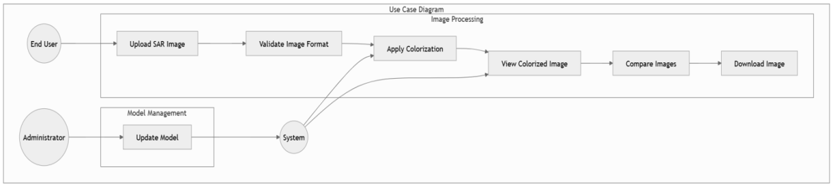

Fig.1

**4.1.2 Class Diagram**

The **Class Diagram** offers a static view of the system, showcasing its structure through classes, attributes, methods, and the relationships among them. It provides a blueprint for how data and functionality are organized.

##### **Purpose:**

* To define the static structure of the system.
* To represent the components and their interconnections.
* To establish relationships between different system modules.

##### **Classes and Descriptions:**

1. **ImageUpload**:
   * **Attributes**:
     + image_path: Stores the path of the uploaded image.
     + file_type: Defines the type of file (e.g., JPG, PNG).
   * **Methods**:
     + upload_image(): Handles image upload from the user.
     + validate_image(): Validates the uploaded image's format and size.
2. **ImageProcessing**:
   * **Attributes**:
     + input_image: The grayscale image to be processed.
     + output_image: The colorized image generated by the model.
   * **Methods**:
     + process_image(): Prepares the image for processing.
     + apply_model(): Applies the CycleGAN model to generate the output.
3. **CycleGANModel**:
   * **Attributes**:
     + model_weights: Contains the pre-trained weights of the CycleGAN model.
     + training_data: The dataset used to train the model.
   * **Methods**:
     + train_model(): Facilitates model training on new datasets.
     + generate_output(): Produces a colorized version of the input image.
4. **UserInterface**:
   * **Attributes**:
     + input_form: Handles the user input for image uploads.
     + output_display: Displays the output images to the user.
   * **Methods**:
     + display_image(): Shows the processed images to the user.
     + show_comparison(): Provides a side-by-side view of the grayscale and colorized images.
5. **AdminControl**:
   * **Attributes**:
     + model_version: Tracks the version of the CycleGAN model in use.
     + system_logs: Stores logs for debugging and maintenance.

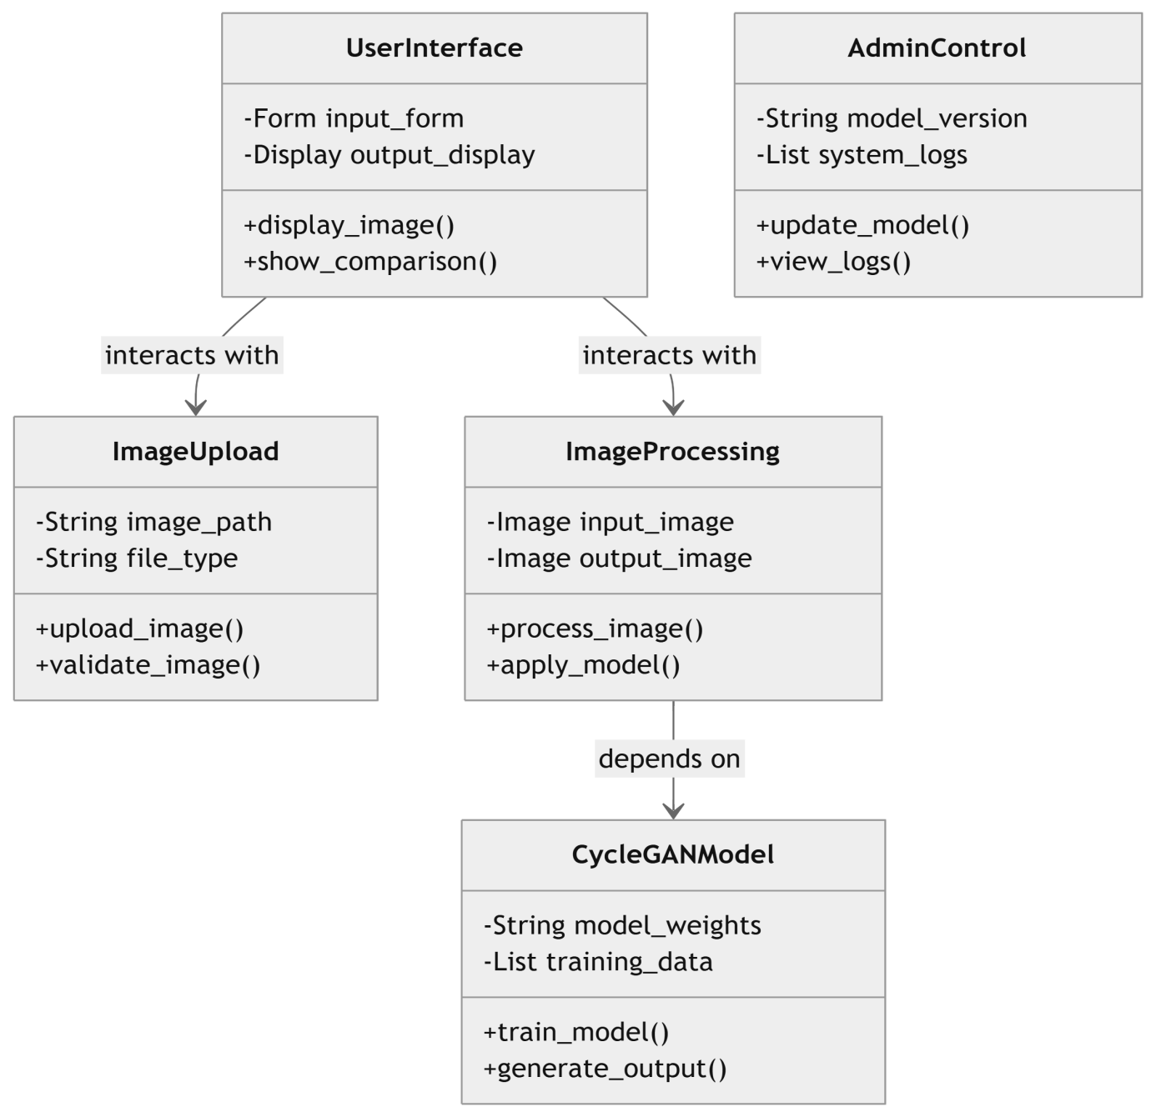

Fig.2

**4.1.3 Sequence Diagram**

The **Sequence Diagram** illustrates the dynamic interaction between various components of the system, focusing on the flow of messages over time.

##### **Purpose:**

* To depict how objects interact in a sequence to accomplish a task.
* To outline the flow of control and data.

##### **Sequence Flow:**

1. The **User** uploads a grayscale SAR image via the **UserInterface**.
2. The **UserInterface** invokes the upload_image() method in the **ImageUpload** class.
3. The **ImageUpload** validates the image format using validate_image().
4. The **ImageProcessing** class processes the image using apply_model() in the **CycleGANModel**.
5. The **CycleGANModel** returns the colorized image to **ImageProcessing**.
6. The **UserInterface** displays the colorized image to the user and offers download functionality.

1

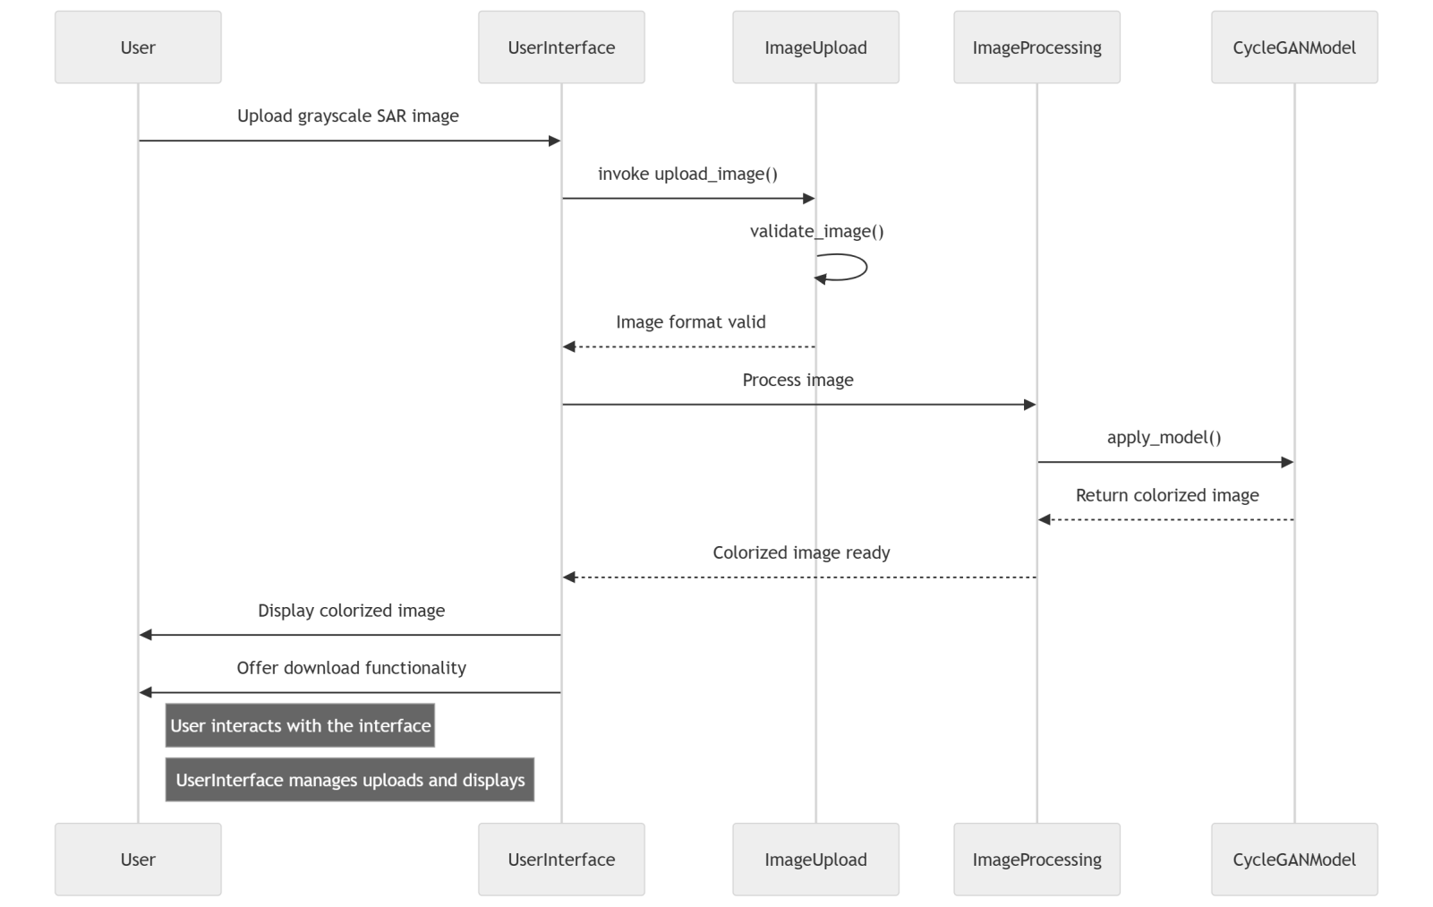

Fig.3

**4.1.4 Activity Diagram**

The **Activity Diagram** provides a detailed view of the workflow within the system, illustrating how tasks are performed in a step-by-step manner.

##### **Key Activities**:

1. **Start**: User opens the application.
2. **Upload Image**: User uploads a grayscale SAR image.
3. **Validate Image**: The system ensures the image meets the required format.
4. **Process Image**: The image is processed by the CycleGAN model.
5. **Generate Output**: A colorized image is produced.
6. **Display Output**: The result is displayed for viewing or downloading.
7. **End**: User completes the interaction.

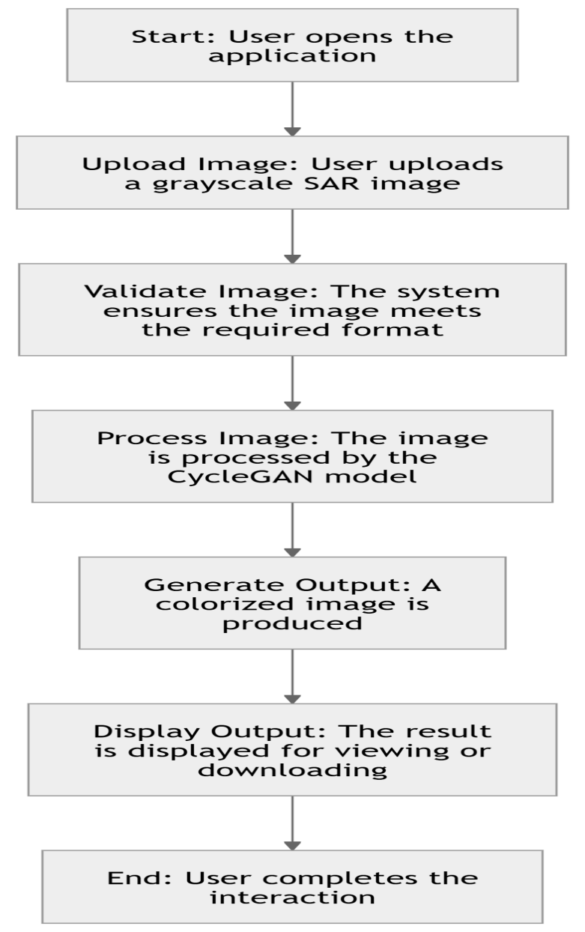

Fig.4

**4.1.5 Collaboration Diagram**

The **Collaboration Diagram** highlights the interaction between objects and their relationships in completing tasks.

##### **Interacting Objects**:

1. **UserInterface**: Initiates interactions and displays results.
2. **ImageUpload**: Manages user uploads.
3. **ImageProcessing**: Executes image processing tasks.
4. **CycleGANModel**: Performs the core task of colorization.

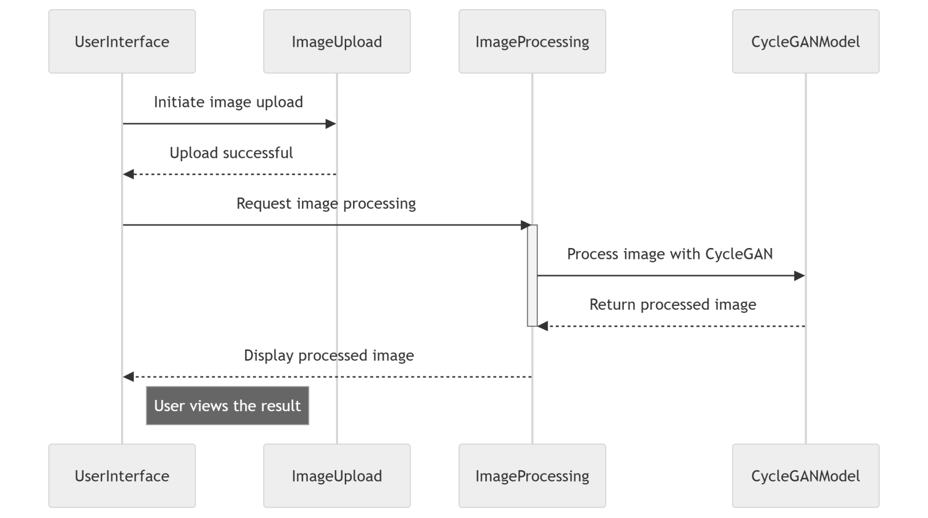

Fig.5

## CHAPTER 5

**IMPLEMENTATION AND RESULT**

**5.1 Method of Implementation**

The project follows a systematic approach to leverage deep learning models for transforming grayscale SAR images into colorized outputs. The implementation is divided into modular steps:

1. **Data Preprocessing**:
   * Normalizing and resizing the SAR images for compatibility with the CycleGAN model.
   * Handling dataset quality to ensure effective training and testing.
2. **Model Development**:
   * Utilizing the CycleGAN deep learning model for unsupervised learning.
   * Training and fine-tuning the model with the Kaggle SAR image dataset.
3. **Deployment**:
   * Developing a user-friendly interface using Streamlit for real-time image uploads and processing.
   * Ensuring compatibility with Intel Iris Xe hardware using Intel's AI Toolkit.
4. **Evaluation**:
   * Validating the model’s performance using various metrics.
   * Conducting visual and quantitative comparisons between grayscale and colorized images.

**5.1.1 Modules**

The project is implemented using the following key modules:

1. **Image Preprocessing Module**:
   * Resizes and normalizes grayscale SAR images for model input.
   * Ensures all images conform to the dimensions required by the CycleGAN model.
2. **CycleGAN Model Module**:
   * Contains the CycleGAN architecture for learning mappings between grayscale and colorized images.
   * Includes training scripts, model weights, and evaluation routines.
3. **Interface Module**:
   * Powered by Streamlit to provide an interactive and accessible web application.
   * Handles image upload, processing, and visualization.

**5.1.2 Software Environment**

The project leverages a robust software environment to ensure efficient execution:

1. **Programming Language**:
   * Python (3.9+) for development.
2. **Libraries and Frameworks**:
   * TensorFlow and PyTorch for deep learning.
   * NumPy and OpenCV for image processing.
   * Streamlit for deployment.
3. **Development Environment**:
   * Jupyter Notebook for model training and debugging.
   * Visual Studio Code for Streamlit application development.
4. **Hardware**:
   * Intel Iris Xe processor with Intel AI Toolkit optimization for model execution.
5. **Dataset**:
   * SAR image dataset sourced from Kaggle for training and testing.

**Python:**

Python is currently the most widely used multi-purpose, high-level programming language. Python allows programming in Object-Oriented and Procedural paradigms. Python programs generally are smaller than other programming languages like Java.

**Python** is a versatile, high-level programming language known for its simplicity and readability, making it an ideal choice for both beginners and experienced developers. Created by **Guido van Rossum** in 1991, Python is an interpreted language that is dynamically typed and supports multiple programming paradigms, including procedural, object-oriented, and functional programming. Its syntax emphasizes readability, which helps reduce the complexity of code and improves maintenance. Python is cross-platform, meaning it runs on various operating systems such as Windows, macOS, and Linux without requiring modification.

Python is widely used in various domains, including **web development**, **data science**, **machine learning**, **automation**, and **game development**. It has an extensive standard library, offering modules for tasks like file handling, networking, and more. Popular frameworks like **Django** and **Flask** are used for web applications, while libraries such as **Pandas**, **NumPy**, and **Matplotlib** are staples in data science. **TensorFlow** and **PyTorch** are widely adopted in machine learning and AI development. Python’s support for third-party libraries and a large, active community ensures that it is adaptable and well-supported for a wide range of applications.

Python is a high-level, interpreted programming language known for its simplicity, readability, and versatility. Created by Guido van Rossum and first released in 1991, Python is designed to emphasize code readability with its clean and straightforward syntax, making it an ideal choice for both beginners and experienced developers. It supports multiple programming paradigms, including procedural, object-oriented, and functional programming, which makes it adaptable for various applications. Python is widely used in fields such as web development, data analysis, artificial intelligence, machine learning, scientific computing, automation, and more, thanks to its extensive standard library and a vast ecosystem of third-party libraries. Tools like NumPy, Pandas, TensorFlow, Flask, and Django have made Python a preferred choice for tasks ranging from data manipulation to web application development and AI research. Its active community ensures continuous improvement, extensive documentation, and support, making Python one of the most popular and powerful programming languages today.

Python’s simplicity makes it a popular choice for beginners, while its powerful features attract seasoned developers. It is widely used in education for teaching programming fundamentals and in industries for real-world applications such as automating repetitive tasks, analyzing massive datasets, creating machine learning models, and building complex web platforms. Python's adaptability, coupled with its strong community support and continuous evolution, ensures its relevance across diverse domains, making it one of the most purposeful and widely used programming languages in the world.

Despite its many advantages, Python has some drawbacks. Being an interpreted language, it can be slower than compiled languages like C or Java, and it is not commonly used for mobile app development. Additionally, the **Global Interpreter Lock (GIL)** limits Python’s ability to fully utilize multi-threading in CPU-bound tasks. Nonetheless, Python's ease of learning, extensive libraries, and flexibility in various fields have made it one of the most popular programming languages in the world today.

Programmers have to type relatively less and indentation requirement of the language, makes them readable all the time. Python language is being used by almost all tech-giant companies like – Google, Amazon, Facebook, Instagram, Dropbox, Uber… etc.

The biggest strength of Python is huge collection of standard libraries which can be used for the following:

* Machine Learning
* GUI Applications (like Kivy, Tkinter, PyQt etc.)
* Web frameworks like Django (used by YouTube, Instagram, Dropbox)
* Image processing (like OpenCV, Pillow)
* Web scraping (like Scrapy, BeautifulSoup, Selenium)
* Test frameworks
* Multimedia.

**Advantages of Python:**

* **Extensive Libraries:**

Python downloads with an extensive library and it contain code for various purposes like regular expressions, documentation-generation, unit-testing, web browsers, threading, databases, CGI, email, image manipulation, and more. So, we don’t have to write the complete code for that manually.

* **Embeddable:**

Complimentary to extensibility, Python is embeddable as well. You can put your Python code in your source code of a different language, like C++. This lets us add scripting capabilities to our code

* **Simple and Easy:**

When working with Java, you may have to create a class to print ‘Hello World’. But in Python, just a print statement will do. It is also quite easy to learn, understand, and code. This is why when people pick up Python, they have a hard time adjusting to other more verbose languages like Java.

* **Readable:**

Because it is not such a verbose language, reading Python is much like reading English. This is the reason why it is so easy to learn, understand, and code. It also does not need curly braces to define blocks, and indentation is mandatory. This further aids to the readability of the code.

* **Object-Oriented:**

This language supports both the procedural and object-oriented programming paradigms. While functions help us with code reusability, classes and objects let us model the real world. A class allows the encapsulation of data and functions into one.

* **Free and Open-Source:**

Python is freely available. But not only can you download Python for free, but you can also download its source code, make changes to it, and even distribute it. It downloads with an extensive collection of libraries to help you with your tasks.

* **Portability:**

When you code your project in a language like C++, you may need to make some changes to it if you want to run it on another platform. But it isn’t the same with Python. Here, you need to code only once, and you can run it anywhere. This is called Write Once Run Anywhere (WORA). However, you need to be careful enough not to include any system-dependent features.

#### Affordable:

#### Python is free therefore individuals, small companies or big organizations can leverage the free available resources to build applications. Python is popular and widely used so it gives you better community support.

**Disadvantages of Python**

* **Speed Limitations:**

We have seen that Python code is executed line by line. But since Python is interpreted, it often results in slow execution. This, however, isn’t a problem unless speed is a focal point for the project. In other words, unless high speed is a requirement, the benefits offered by Python are enough to distract us from its speed limitations.

* **Weak in Mobile Computing and Browsers:**

While it serves as an excellent server-side language, Python is much rarely seen on the client side. Besides that, it is rarely ever used to implement smartphone-based applications. One such application is called Carbonnella. The reason it is not so famous despite the existence of Brython is that it isn’t that secure.

* **Design Restrictions:**

As you know, Python is dynamically-typed. This means that you don’t need to declare the type of variable while writing the code. It uses duck-typing. But wait, what’s that? Well, it just means that if it looks like a duck, it must be a duck. While this is easy on the programmers during coding, it can raise run-time errors.

* **Underdeveloped Database Access Layers:**

Compared to more widely used technologies like JDBC (Java Database Connectivity) and ODBC (Open Database Connectivity), Python’s database access layers are a bit underdeveloped. Consequently, it is less often applied in huge enterprises.

* **Simple:**

Python’s simplicity can indeed be a problem. Take my example. I don’t do Java, I’m more of a Python person. To me, its syntax is so simple that the verbosity of Java code seems unnecessary.

**History of Python:**

What do the alphabet and the programming language Python have in common? Right, both start with ABC. If we are talking about ABC in the Python context, it's clear that the programming language ABC is meant. ABC is a general-purpose programming language and programming environment, which had been developed in the Netherlands, Amsterdam, at the CWI (Centrum Wiskunde &Informatica). The greatest achievement of ABC was to influence the design of Python. Python was conceptualized in the late 1980s. Guido van Rossum worked that time in a project at the CWI, called Amoeba, a distributed operating system. In an interview with Bill Venners1, Guido van Rossum said: "In the early 1980s, I worked as an implementer on a team building a language called ABC at Centrum voor Wiskunde en Informatica (CWI). I don't know how well people know ABC's influence on Python. I try to mention ABC's influence because I'm indebted to everything I learned during that project and to the people who worked on it”. Later on in the same Interview, Guido van Rossum continued: "I remembered all my experience and some of my frustration with ABC. I decided to try to design a simple scripting language that possessed some of ABC's better properties, but without its problems. So, I started typing. I created a simple virtual machine, a simple parser, and a simple runtime. I made my own version of the various ABC parts that I liked. I created a basic syntax, used indentation for statement grouping instead of curly braces or begin-end blocks, and developed a small number of powerful data types: a hash table (or dictionary, as we call it), a list, strings, and numbers." Over the years, Python has grown exponentially in popularity, becoming a favorite for various domains like web development, data science, machine learning, artificial intelligence, and scientific computing. This growth has been fueled by an active community, a rich ecosystem of libraries, and its use in educational contexts. As of January 1, 2020, Python 2.x officially reached its end of life, solidifying Python 3.x as the future

#### What is Machine Learning:

#### Before we take a look at the details of various machine learning methods, let's start by looking at what machine learning is, and what it isn't. Machine learning is often categorized as a subfield of artificial intelligence, but I find that categorization can often be misleading at first brush.

#### The study of machine learning certainly arose from research in this context, but in the data science application of machine learning methods, it's more helpful to think of machine learning as a means of building models of data. Fundamentally, machine learning involves building mathematical models to help understand data. "Learning" enters the fray when we give these models tunable parameters that can be adapted to observed data; in this way the program can be considered to be "learning" from the data. Once these models have been fit to previously seen data, they can be used to predict and understand aspects of newly observed data. I'll leave to the reader the more philosophical digression regarding the extent to which this type of mathematical, model-based "learning" is similar to the "learning" exhibited by the human brain. Understanding the problem setting in machine learning is essential to using these tools effectively, and so we will start with some broad categorizations of the types of approaches we'll discuss here.

#### Categories Of Machine Leaning:

#### At the most fundamental level, machine learning can be categorized into two main types: supervised learning and unsupervised learning. Supervised learning involves somehow modeling the relationship between measured features of data and some label associated with the data; once this model is determined, it can be used to apply labels to new, unknown data. This is further subdivided into classification tasks and regression tasks: in classification, the labels are discrete categories, while in regression, the labels are continuous quantities. We will see examples of both types of supervised learning in the following section. Un-supervised learning involves modeling the features of a dataset without reference to any label, and is often described as "letting the dataset speak for itself." These models include tasks such as clustering and dimensionality reduction. Clustering

#### Need for Machine Learning:

#### Human beings, at this moment, are the most intelligent and advanced species on earth because they can think, evaluate and solve complex problems. On the other side, AI is still in its initial stage and haven’t surpassed human intelligence in many aspects. Then the question is that what is the need to make machine learn? The most suitable reason for doing this is, “to make decisions, based on data, with efficiency and scale”.

#### In an interview with Bill Venners1, Guido van Rossum said: "In the early 1980s, I worked as an implementer on a team building a language called ABC at Centrum voor Wiskunde en Informatica (CWI). I don't know how well people know ABC's influence on Python. I try to mention ABC's influence because I'm indebted to everything I learned during that project and to the people who worked on it”. Later on in the same Interview, Guido van Rossum continued: "I remembered all my experience and some of my frustration with ABC. I decided to try to design a simple scripting language that possessed some of ABC's better properties, but without its problems. So, I started typing. I created a simple virtual machine, a simple parser, and a simple runtime. I made my own version

#### Lately, organizations are investing heavily in newer technologies like Artificial Intelligence, Machine Learning and Deep Learning to get the key information from data to perform several real-world tasks and solve problems. We can call it data-driven decisions taken by machines, particularly to automate the process. These data-driven decisions can be used, instead of using programing logic, in the problems that cannot be programmed inherently. The fact is that we can’t do without human intelligence, but other aspect is that we all need to solve real-world problems with efficiency at a huge scale. That is why the need for machine learning arises.

#### Machine learning enables systems to automatically learn from data and improve their performance without explicit programming, making it essential for solving problems in diverse fields. It powers applications like recommendation systems, fraud detection, speech recognition, self-driving cars, and medical diagnostics, where manually coding rules is infeasible. By identifying patterns, making predictions, and adapting to new information, machine learning helps businesses make data-driven decisions, enhances user experiences, and drives innovation in technology, healthcare, finance, and more. Its ability to process vast amounts of data efficiently and uncover insights has made it indispensable in modern industries.

#### Challenges in Machines Learning:

#### While Machine Learning is rapidly evolving, making significant strides with cybersecurity and autonomous cars, this segment of AI as whole still has a long way to go. The reason behind is that ML has not been able to overcome number of challenges. The challenges that ML is facing currently are:

#### Quality of data − Having good-quality data for ML algorithms is one of the biggest challenges. Use of low-quality data leads to the problems related to data preprocessing and feature extraction.

#### Time-Consuming task − Another challenge faced by ML models is the consumption of time especially for data acquisition, feature extraction and retrieval.

#### Lack of specialist persons − As ML technology is still in its infancy stage, availability of expert resources is a tough job.

#### No clear objective for formulating business problems − Having no clear objective and well- defined goal for business problems is another key challenge for ML because this technology is not that mature yet.

#### Issue of overfitting & underfitting − If the model is overfitting or underfitting, it cannot be represented well for the problem.

#### Curse of dimensionality − Another challenge ML model faces is too many features of data points. This can be a real hindrance.

#### Difficulty in deployment − Complexity of the ML model makes it quite difficult to be deployed in real life.

#### Applications of Machines Learning:

#### Machine Learning is the most rapidly growing technology and according to researchers we are in the golden year of AI and ML. It is used to solve many real-world complex problems which cannot be solved with traditional approach. Following are some real-world applications of ML

#### Emotion analysis

#### Sentiment analysis

#### Error detection and prevention

#### Weather forecasting and prediction

#### Stock market analysis and forecasting

#### Speech synthesis

#### Speech recognition

#### Customer segmentation

#### Object recognition

#### Fraud detection

#### How to Start Learning Machine Learning?

#### Arthur Samuel coined the term “Machine Learning” in 1959 and defined it as a “Field of study that gives computers the capability to learn without being explicitly programmed”. And that was the beginning of Machine Learning! In modern times, Machine Learning is one of the most popular (if not the most!) career choices. According to Indeed, Machine Learning Engineer Is the Best Job of 2019 with a 344% growth and an average base salary of $146,085 per year.

#### But there is still a lot of doubt about what exactly is Machine Learning and how to start learning it? So, this article deals with the Basics of Machine Learning and also the path you can follow to eventually .

#### How to start learning ML?

#### Step 1 – Understand the Prerequisites

#### In case you are a genius, you could start ML directly but normally, there are some prerequisites that you need to know which include Linear Algebra, Multivariate Calculus, Statistics, and Python. And if you don’t know these, never fear! You don’t need a Ph.D. degree in these topics to get started but you do need a basic understanding.

#### (a)Learn Linear Algebra and Multivariate Calculus

#### Both Linear Algebra and Multivariate Calculus are important in Machine Learning. However, the extent to which you need them depends on your role as a data scientist. If you are more focused on application heavy machine learning, then you will not be that heavily focused on math as there are many common libraries available. But if you want to focus on R&D in Machine Learning, then mastery of Linear Algebra and Multivariate Calculus is very important as you will have to implement many ML algorithms from scratch.

#### (b)Learn Statistics

#### Data plays a huge role in Machine Learning. In fact, around 80% of your time as an ML expert will be spent collecting and cleaning data. And statistics is a field that handles the collection, analysis, and presentation of data. So, it is no surprise that you need to learn it!!!

#### Some of the key concepts in statistics that are important are Statistical Significance, Probability Distributions, Hypothesis Testing, Regression, etc. Also, Bayesian Thinking is also a very important part of ML which deals with various concepts like Conditional Probability, Priors, and Posteriors, Maximum Likelihood, etc.

#### (c)Learn Python

#### Step1:-

#### Some people prefer to skip Linear Algebra, Multivariate Calculus and Statistics and learn them as they go along with trial and error. But the one thing that you absolutely cannot skip is Python! While there are other languages you can use for Machine Learning like R, Scala, etc. Python is currently the most popular language for ML. In fact, there are many Python libraries that are specifically useful for Artificial Intelligence and Machine Learning such as Keras, TensorFlow, Scikit-learn, etc.

#### 

#### Step 2 :–

#### Learn Various ML Concepts Now that you are done with the prerequisites, you can move on to actually learning ML (Which is the fun part!!!) It’s best to start with the basics and then move on to the more complicated stuff. Some of the basic concepts in ML are:

#### (a)Terminologies of Machine Learning

#### Model – A model is a specific representation learned from data by applying some machine learning algorithm. A model is also called a hypothesis.

#### Feature – A feature is an individual measurable property of the data. A set of numeric features can be conveniently described by a feature vector. Feature vectors are fed as input to the model. For example, in order to predict a fruit, there may be features like color, smell, taste, etc.

#### Target (Label) – A target variable or label is the value to be predicted by our model. For the fruit example discussed in the feature section, the label with each set of input would be the name of the fruit like apple, orange, banana, etc.

#### Training – The idea is to give a set of inputs(features) and it’s expected outputs(labels), so after training, we will have a model (hypothesis)

#### (b)Types of Machine Learning

#### Supervised Learning – This involves learning from a training dataset with labeled data using classification and regression models. This learning process continues until the required level of performance is achieved.

#### Unsupervised Learning – This involves using unlabeled data and then finding the underlying structure in the data in order to learn more and more about the data itself using factor and cluster analysis models.

#### Semi-supervised Learning – This involves using unlabeled data like Unsupervised Learning with a small amount of labeled data. Using labeled data vastly increases the learning accuracy and is also more cost-effective than Supervised Learning.

#### Reinforcement Learning – This involves learning optimal actions through trial and error. So, the next action is decided by learning behaviors that are based on the current state and that will maximize the reward in the future.

#### Advantages of Machine learning:

#### Easily identifies trends and patterns:

#### Machine Learning can review large volumes of data and discover specific trends and patterns that would not be apparent to humans. For instance, for an e-commerce website like Amazon, it serves to understand the browsing behaviors and purchase histories of its users to help cater to the right products, deals, and reminders relevant to them. It uses the results to reveal relevant advertisements to them.

#### No human intervention needed (automation):

#### With ML, you don’t need to babysit your project every step of the way. Since it means giving machines the ability to learn, it lets them make predictions and also improve the algorithms on their own. A common example of this is anti-virus software; they learn to filter new threats as they are recognized. ML is also good at recognizing spam.

#### Continuous Improvement:

#### As ML algorithms gain experience, they keep improving in accuracy and efficiency. This lets them make better decisions. Say you need to make a weather forecast model. As the amount of data you have keeps growing, your algorithms learn to make more accurate predictions faster.

#### Handling multi-dimensional and multi-variety data:

#### Machine Learning algorithms are good at handling data that are multi-dimensional and multi- variety, and they can do this in dynamic or

#### Wide Applications:

#### You could be an e-tailer or a healthcare provider and make ML work for you. Where it does apply, it holds the capability to help deliver a much more personal experience to customers while also targeting the right customers.

#### Advanced Pattern Recognition:

#### By identifying complex and hidden patterns in data, ML can detect anomalies, predict future trends, and generate actionable insights. For instance, it can recognize fraud in transactions or detect diseases in medical images.

#### Continuous Improvement:

#### Unlike static systems, ML models improve their performance over time as they are exposed to more data. This ability ensures that predictions and decision-making become more accurate with ongoing use.

#### Adaptability to Changing Environments:

#### ML systems adapt to dynamic environments and new datasets without needing explicit reprogramming, making them robust and versatile in evolving conditions.

#### Wide Range of Applications:

#### ML is versatile and can be applied across industries. In healthcare, it assists in diagnosing diseases. In finance, it predicts stock trends. In retail, it optimizes inventory, and in technology, it powers virtual assistants and chatbots.

* **Efficient Data Analysis:**

ML processes and analyses massive amounts of data quickly and accurately, uncovering insights that would take humans much longer to identify. This capability is essential in data-driven industries like healthcare, finance, and marketing.

* **Automation of Tasks:** Machine learning automates repetitive and time-consuming tasks, reducing the need for human intervention. For example, it can classify emails as spam, detect defects in manufacturing, or optimize logistics routes without manual oversight.

#### Disadvantages of Machine Learning:

#### Data Acquisition:

#### Machine Learning requires massive data sets to train on, and these should be inclusive/unbiased, and of good quality. There can also be times where they must wait for new data to be generated.

#### Time and Resources:

#### ML needs enough time to let the algorithms learn and develop enough to fulfill their purpose with a considerable amount of accuracy and relevancy. It also needs massive resources to function. This can mean additional requirements of computer power for you.

#### Interpretation of Results:

#### Another major challenge is the ability to accurately interpret results generated by the algorithms. You must also carefully choose the algorithms for your purpose.

#### High error-susceptibility:

#### Machine Learning is autonomous but highly susceptible to errors. Suppose you train an algorithm with data sets small enough to not be inclusive. You end up with biased predictions coming from a biased training set. This leads to irrelevant advertisements being displayed to customers. In the case of ML, such blunders can set off a chain of errors that can go undetected for long periods of time. And when they do get noticed, it takes quite some time to recognize the source of the issue, and even longer to correct it.

#### 

#### Python Development Steps:

Guido Van Rossum published the first version of Python code (version 0.9.0) at alt.sources in February 1991. This release included already exception handling, functions, and the core data types of lists, dict, str and others. It was also object oriented and had a module system.

Python version 1.0 was released in January 1994. The major new features included in this release were the functional programming tools lambda, map, filter and reduce, which Guido Van Rossum never liked.Six and a half years later in October 2000, Python 2.0 was introduced. This release included list comprehensions, a full garbage collector and it was supporting uni-code. Python flourished for another 8 years in the versions 2.x before the next major release as Python 3.0 (also known as "Python 3000" and "Py3K") was released. Python 3 is not backwards compatible with Python 2.x. The emphasis in Python 3 had been on the removal of duplicate programming constructs and modules, thus fulfilling or coming close to fulfilling the 13th law of the Zen of Python: "There should be one -- and preferably only one -- obvious way to do it

Some changes in Python 7.3:

* Print is now a function
* Views and iterators instead of lists.
* The rules for ordering comparisons have been simplified. E.g. a heterogeneous list cannot be sorted, because all the elements of a list must be comparable to each other.
* There is only one integer type left, i.e. int. long is int as well.
* The division of two integers returns a float instead of an integer.
* Text Vs. Data Instead of Unicode Vs. 8-bit

**Purpose:**

We demonstrated that our approach enables successful segmentation of intra-retinal layers— even with low-quality images containing speckle noise, low contrast, and different intensity ranges throughout— with the assistance of the ANIS feature. Python is an interpreted high-level programming language for general-purpose programming. Created by Guido van Rossum and first released in 1991, Python has a design philosophy that emphasizes code readability, notably using significant whitespace.

Python features a dynamic type system and automatic memory management. It supports multiple programming paradigms, including object-oriented, imperative, functional and procedural, and has a large and comprehensive standard library. Python also acknowledges that speed of development is important. One of Python’s strengths is its extensive standard library, which provides built-in modules and functions for tasks such as file handling, networking, and web scraping, eliminating the need to write repetitive code. Additionally, Python has a vibrant ecosystem of third-party libraries like NumPy for numerical computing, Pandas for data analysis, TensorFlow and PyTorch for machine learning, and Django for web development. These libraries extend Python’s capabilities, enabling it to excel in areas like scientific computing, artificial intelligence, automation, and web application development.

Python’s simplicity makes it a popular choice for beginners, while its powerful features attract seasoned developers. It is widely used in education for teaching programming fundamentals and in industries for real-world applications such as automating repetitive tasks, analyzing massive datasets, creating machine learning models, and building complex web platforms. Python's adaptability, coupled with its strong community support and continuous evolution, ensures its relevance across diverse domains, making it one of the most purposeful and widely used programming languages in the world.

## Modules used in project:

* **CV2:**

The CV2 module is part of OpenCV, a library for computer vision and image processing. It offers tools for tasks like image manipulation, object detection, face recognition, video analysis, and machine learning. Key features include image transformations, video capture, feature detection, and camera calibration, making it widely used in Python for developing AI models and interactive applications.

* **OS:**

The os module in Python allows interaction with the operating system. It provides functions for file and directory management, path manipulation, environment variable access, and process management. Key features include file operations (os.rename(), os.remove()), path handling (os.path.join()), and working with environment variables (os.getenv()). It also allows running system

* **PANDAS:**

The PANDAS module is a powerful library for data manipulation and analysis, offering DataFrame and Series for handling data. It supports reading/writing data, data cleaning, statistical analysis, and time series operations. Widely used in data science and machine learning, it simplifies data preprocessing and analysis tasks.

* **NUMPY:**

The numpy module is a fundamental library for numerical computing in Python. It provides support for large, multi-dimensional arrays and matrices, along with a collection of mathematical functions to operate on them. numpy is essential for tasks such as linear algebra, statistical analysis, and data manipulation.

* **CVZONE:**

The cvzone module is a Python library built on top of OpenCV, designed to simplify computer vision tasks. It provides easy-to-use functions for real-time face detection, hand tracking, object detection, and pose estimation. With its high-level abstractions, cvzone makes it easier to work with complex computer vision applications, offering intuitive tools for developers and simplifying tasks like drawing on images, processing webcam feeds, and

**How to Install Python on Windows:**

There have been several updates in the Python version over the years. The question is how to install Python? It might be confusing for the beginner who is willing to start learning Python but this tutorial will solve your query. The latest or the newest version of Python is version 3.7.4 or in other words, it is Python 3.

#### Download the Correct version into the system

#### Step 1: Go to the official site to download and install python using Google Chrome Click on the following link: [https://www.python.org](https://www.python.org/)

Fig.6

Now, check for the latest and the correct version for your operating system.

**Step 2:-** Click on the Download Tab.

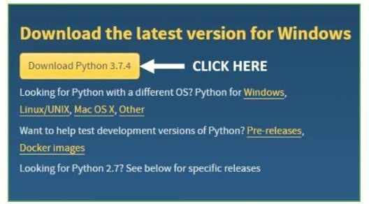

Fig.7

**Step 3: -**You can either select the Download Python for windows 3.7.4 button in yellow color or you can scroll further down and click on download with respective to their version. Here we are downloading the most recent python version for windows 3.7.4.

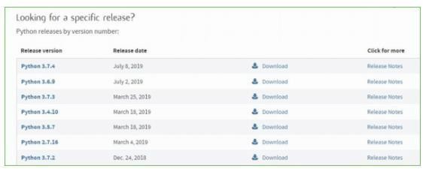

Fig.8

**Step 4: -**Scroll down the page until you find the Files option.

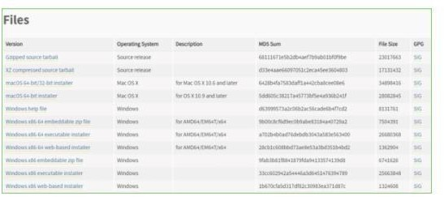

Fig.9

* **Installation of Python**

### Step 1:- Go to Download and Open the downloaded python version to carry ou

Fig.10

**Step 2:-** Before you click on Install Now, Make sure to put a tick

Add Python 3.7 to PATH.

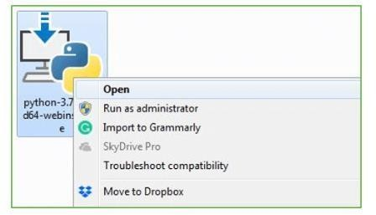

Fig.11

**Step 3: -**Click on Install NOW After the installation is successful. Click on Close.



Fig.12

* **Verify the Python Installation**

**Step 1:** -Click on Start

**Step 2:-** In the Windows Run Command, type “cmd”.

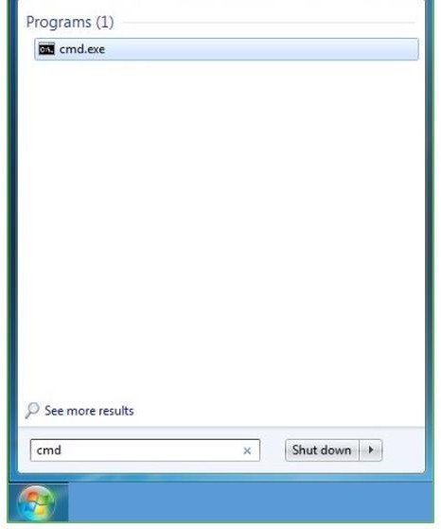

Fig.13

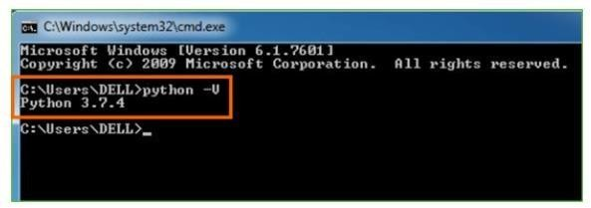 **Step 3:** -Open the Command prompt option.

**Step 4: -**Let us test whether the python is correctly installed. Type

python –V and press Enter.

Fig.14

**Step 5:** You will get the answer as 3.7.4

* **Check how the Python IDLE works**

**Step 1:-** Click on Start

**Step 2: -**In the Windows Run command, type “python idle”.

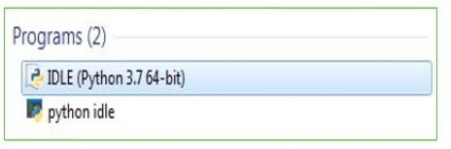

Fig.15

**Step 3: -**Click on IDLE (Python 3.7 64-bit) and launch the program

**Step 4:-** To go ahead with working in IDLE you must first save the file. Click on File >

Click on Save

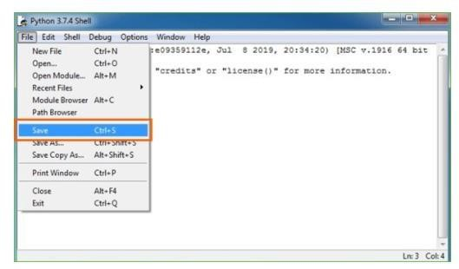

Fig.16

**Step 5:-** Name the file and save as type should be Python files. Click on SAVE.

**Step 6:** -Now for e.g. enter print

**5.2 Output Screen**

* **Home Screen**:
* A welcoming interface guiding users to upload grayscale images.
* **Image Upload Screen**:
* Provides options for uploading images and displays uploaded grayscale images.
* **Processing Screen**:
* Shows progress and model output after colorization.
* **Comparison Screen**:
* Displays side-by-side views of original grayscale and colorized images.
* **Download Screen**:
* Allows users to download the colorized images.

**Step 1:-**streamlit

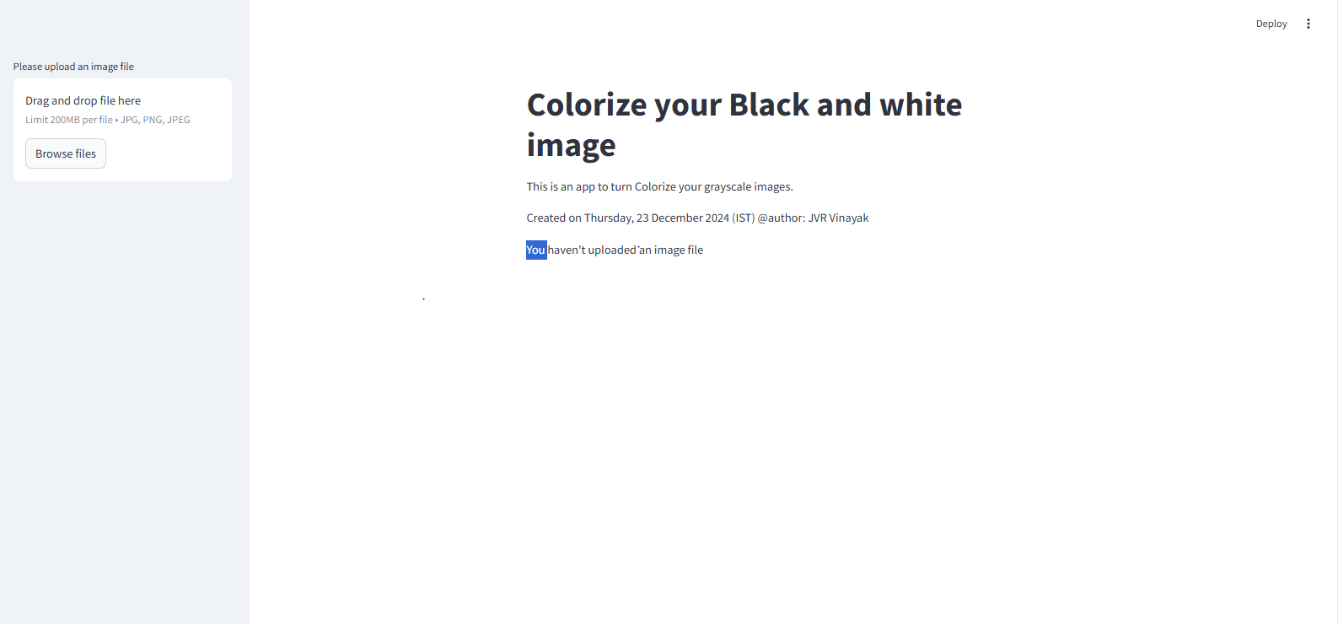

Fig.17

**Step2:-**try to insert a grayscale picture

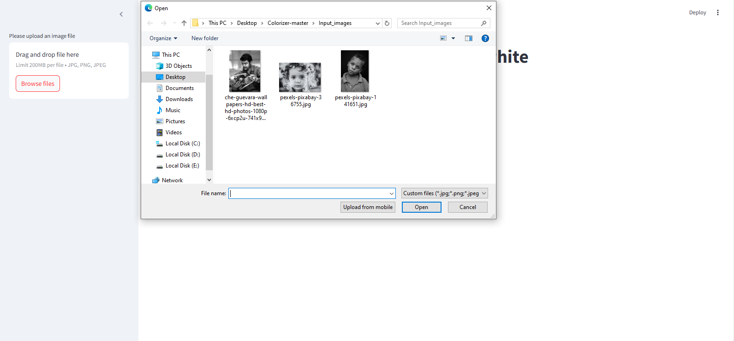

Fig.18

**Step3:-**after inserting a grayscale picture

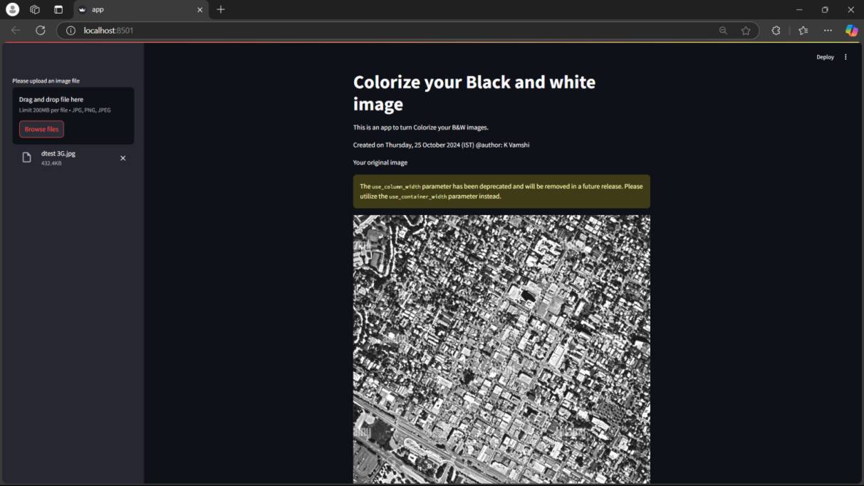

Fig.19

**Step4:-**the optical image as came as output

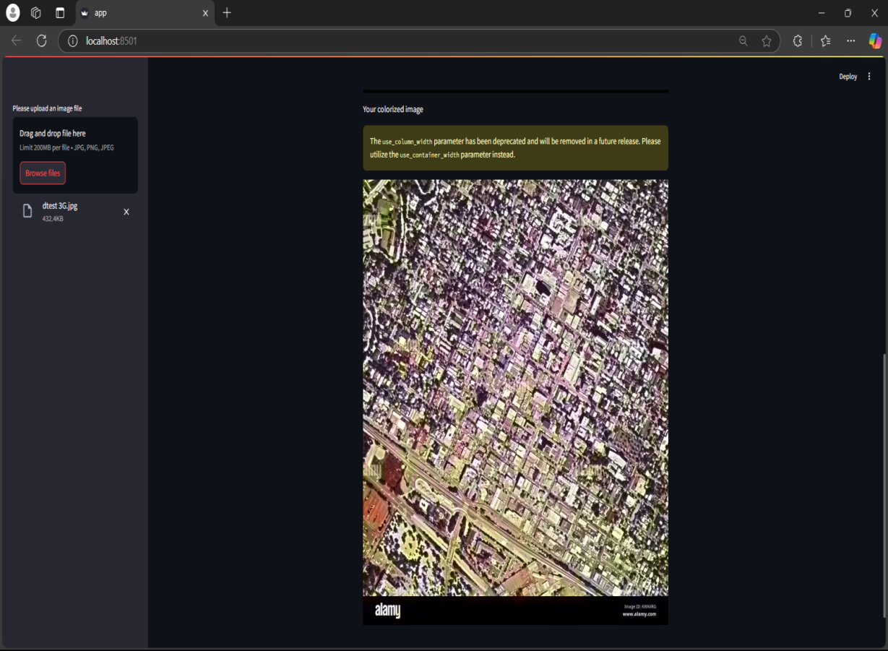

Fig.20

## CHAPTER 6

**SYSTEM TESTING**

* 1. **Types of Testing**

**Unit Testing**:

* Verifies that individual modules or components work as expected.
* Example: Testing the colorizer function with a sample grayscale image to ensure the output is correctly colorized.

**Integration Testing**:

* Checks the interaction between integrated components, such as cv2 and the pre-trained models.
* Example: Ensuring seamless interaction between the uploaded image, colorization model, and the Streamlit app.

**System Testing**:

* Validates the end-to-end functionality of the entire application.
* Example: Uploading a grayscale image and verifying the system generates and displays the colorized image correctly.

**User Acceptance Testing (UAT)**:

* Ensures the system meets user requirements.
* Example: Confirming users can easily upload images and receive accurate colorized outputs without errors.

**6.2 Test Cases**

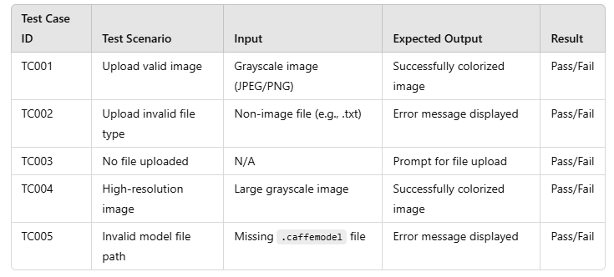

## CHAPTER 7

**CONCLUSION**

#### ****7.1 Project Conclusion****

The SAR Image Colorization project successfully demonstrates the potential of deep learning in enhancing grayscale SAR images for better interpretability. By implementing the CycleGAN model within a Streamlit application, we provide an intuitive and efficient interface for colorizing images. This project can be instrumental in various domains, including environmental monitoring, disaster management, and urban planning.

#### ****7.2 Future Enhancement****

#### 

* **Model Optimization**: Explore advanced architectures like Vision Transformers (ViTs) or Stable Diffusion for enhanced accuracy.
* **Real-Time Processing**: Integrate GPU acceleration to enable real-time colorization for video feeds.
* **User Customization**: Allow users to fine-tune parameters like color intensity or add region-specific adjustments.
* **Deployment**: Host the application on cloud platforms such as AWS or Azure for scalability and accessibility.

**REFERENCES**

1. Goodfellow, I., et al. (2014). "Generative Adversarial Networks." Advances in Neural Information Processing Systems (NeurIPS).
2. Zhang, R., Isola, P., & Efros, A. A. (2016). "Colorful Image Colorization." European Conference on Computer Vision (ECCV).
3. Zhu, J. Y., et al. (2017). "Unpaired Image-to-Image Translation Using Cycle-Consistent Adversarial Networks." International Conference on Computer Vision (ICCV).
4. Intel OpenVINO Toolkit Documentation (2024). Retrieved from <https://www.intel.com>.
5. Kaggle Dataset: "SAR Images for Machine Learning." Retrieved from <https://www.kaggle.com>.

**APPENDIX**

**CODE**

#Importing required libraries

import numpy as np

import cv2

import streamlit as st

from PIL import Image

import os

def colorizer(img):

# Convert the image to grayscale, then back to RGB

img = cv2.cvtColor(img, cv2.COLOR_BGR2GRAY)

img = cv2.cvtColor(img, cv2.COLOR_GRAY2RGB)

# Define absolute paths for the model files

prototxt = r"C:\Users\saiva\OneDrive\Desktop\Colorizer- master\models\models_colorization_deploy_v2.prototxt"

model = r"C:\Users\saiva\OneDrive\Desktop\Colorizer-master\models\colorization_release-v2.caffemodel"

points = r"C:\Users\saiva\OneDrive\Desktop\Colorizer-master\models\pts_in_hull.npy"

# Load the pre-trained model

net = cv2.dnn.readNetFromCaffe(prototxt, model)

pts = np.load(points)

# Add the cluster centers as 1x1 convolutions to the model

class8 = net.getLayerId("class8_ab")

conv8 = net.getLayerId("conv8_313_rh")

pts = pts.transpose().reshape(2, 313, 1, 1)

net.getLayer(class8).blobs = [pts.astype("float32")]

net.getLayer(conv8).blobs = [np.full([1, 313], 2.606, dtype="float32")]

# Preprocess the image

scaled = img.astype("float32") / 255.0

lab = cv2.cvtColor(scaled, cv2.COLOR_RGB2LAB)

# Resize the Lab image to 224x224, split channels, and extract the 'L' channel

resized = cv2.resize(lab, (224, 224))

L = cv2.split(resized)[0]

L -= 50

# Feed the 'L' channel to the network to predict the 'a' and 'b' channel values

net.setInput(cv2.dnn.blobFromImage(L))

ab = net.forward()[0, :, :, :].transpose((1, 2, 0))

# Resize the predicted 'ab' channels to the original image size

ab = cv2.resize(ab, (img.shape[1], img.shape[0]))

# Concatenate the 'L' channel with the predicted 'a' and 'b' channels

L = cv2.split(lab)[0]

colorized = np.concatenate((L[:, :, np.newaxis], ab), axis=2)

# Convert the colorized image from Lab to RGB and clip any values outside the range [0, 1]

colorized = cv2.cvtColor(colorized, cv2.COLOR_LAB2RGB)

colorized = np.clip(colorized, 0, 1)

# Convert the floating-point image to uint8 for display

colorized = (255 * colorized).astype("uint8")

return colorized

# Streamlit UI

st.write("""

# Colorize Your Black and White Image

"""

)

st.write("This is an app to colorize your B&W images.")

st.write("# Created on Thursday, 12 December 2024 (IST) @author: Vinayak")

# Image uploader widget

file = st.sidebar.file_uploader("Please upload an image file", type=["jpg", "png"])

if file is None:

st.text("You haven't uploaded an image file")

else:

# Open and display the uploaded image

image = Image.open(file)

img = np.array(image)

st.text("Your original image")

st.image(image, use_column_width=True)

# Process and display the colorized image

st.text("Your colorized image")

color = colorizer(img)

st.image(color, use_column_width=True)

print("done!")

# In[ ]: